https://www.jdoodle.com/embed/v0/66Z1
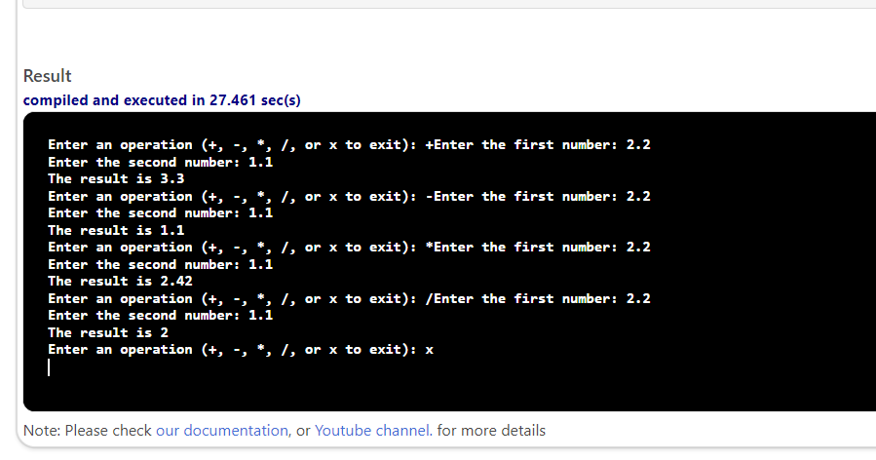

#include <iostream>
using namespace std;

double calculate(char op, double n1, double n2);
int main()
{
char oper;
double num1, num2, result;
do
{
cout << "Enter an operation (+, -, *, /, or x to exit): ";
cin >> oper;
if (oper == '+' || oper == '-' || oper == '*' || oper == '/')
{
cout << "Enter the first number: ";
cin >> num1;
cout << "Enter the second number: ";
cin >> num2;
result = calculate(oper, num1, num2);
cout << "The result is " << result << endl;
}

}
while (oper != 'x');
return 0;
}

double calculate(char op, double n1, double n2)

{
double res;
switch (op)
{

case '+':
res = n1 + n2;
break;
case '-':
res = n1 - n2;
break;
case '*':
res = n1 * n2;
break;
case '/':
res = n1 / n2;
break;
}
return res;
}

